**Sentiment Analysis Of Social Media Presence**

Koniki Ganesh, Student  
Department of Computer Science and Engineering, Presidency University

P Srinivas, Student  
Department of Computer Science and Engineering, Presidency University

Y Sai Pallavi, Student  
Department of Computer Science and Engineering, Presidency University

B Saikumar, Student  
Department of Computer Science and Engineering, Presidency University

Dr.Swapna M  
School of Computer Science and Engineering, Presidency University

**ABSTRACT**

The rise of social media platforms has led to an unprecedented volume of user-generated content, making sentiment analysis a crucial tool for understanding public opinion, brand perception, and social trends. This paper explores various machine learning and natural language processing (NLP) techniques used in sentiment analysis, including lexicon-based methods, supervised and unsupervised learning models, and hybrid approaches. A comparative analysis of existing sentiment analysis models, their accuracy, and application areas is provided. The study also discusses challenges such as handling sarcasm, multilingual data, and contextual ambiguity. The findings highlight the importance of sentiment analysis in fields like politics, healthcare, business intelligence, and crisis management.

Sentiment analysis of social media presence has become a critical research area, driven by the rapid growth of user-generated content on platforms like Twitter, Facebook, and Instagram. This study explores various sentiment analysis techniques, including lexicon-based, machine learning, and hybrid models, to classify social media posts into different sentiment categories. Sentiment classification accuracy can be improved with the help of artificial intelligence and machine learning approaches like Random forest classifier, decision tree, XG Boost.

However, despite these advancements, challenges remain in areas such as sarcasm detection, multilingual text processing, and real-time sentiment analysis. The research has underlined the importance of sentiment analysis in real-world applications such as marketing, politics, finance, healthcare, and crisis management. Future developments in explainable AI, cross-lingual analysis, and advanced deep learning techniques will further enhance the capabilities of sentiment analysis, making it an indispensable tool for businesses, researchers, and policymakers.

Sentiment analysis is a critical tool that businesses, governments, and researchers use to analyse public opinion in social media. This paper reviews the techniques of sentiment analysis along with their use cases in marketing, healthcare, politics, and finance. AI techniques, such as deep learning and hybrid models, have proven useful to provide insight into consumer behaviour and public discourse. The field, however, still trails behind in analysing complex emotions, sarcasm, and multilingual data. By refining the techniques of sentiment analysis and incorporating real-time monitoring capabilities, organizations can enhance decision-making, improve customer engagement, and detect emerging trends more effectively.

**KEY WORDS**

Sentiment Analysis, Social Media, Machine Learning, Natural Language Processing, Opinion Mining, Social Media Analytics, Text Classification.

**INTRODUCTION**

The rise of social media has revolutionized how individuals, businesses, and organizations interact, communicate, and share information. Platforms such as Twitter, Facebook, and Instagram generate massive amounts of data daily, offering valuable insights into user sentiments, opinions, and trends. Sentiment analysis, also known as opinion mining, has emerged as a crucial tool for analyzing this data, allowing businesses to gauge customer feedback, monitor brand perception, and make data-driven decisions. Traditional sentiment analysis techniques relied on lexicon-based approaches, but advancements in machine learning and deep learning have significantly improved accuracy and scalability. However, several challenges remain, including sarcasm detection, contextual ambiguity, and multilingual text processing. This study explores state-of-the-art sentiment analysis techniques, their applications, and the future scope of AI-driven sentiment analysis in various domains.

AI and Machine Learning Perspective:

Modern social media platforms play a crucial role in the shaping of opinions and consumer behaviour while providing real-time insights into trends in society. The sheer volume of user-generated content has demanded the use of AI and ML techniques to process sentiment efficiently. Textual sentiment analysis applies AI-based models like Random forest classifier, decision tree, XG Boost and deep learning frameworks, like lstm and bert, in order to categorize the text as positive, negative, or neutral. However, the present models lack proper accuracy and efficiency in cases involving sarcasm, evolving slang, and multilingual sentiment classification. This research explores the potential of AI-powered sentiment analysis, highlighting its role in business intelligence, public policy, and customer experience management.

Real-World Applications Perspective:

In the digital age, social media has been a strong avenue for public expression, and opinions are expressed regarding products, services, politics, and world events. With so much textual data to analyse and interpret, it has given birth to the concept of sentiment analysis techniques. Companies benefit from sentiment analysis for enhancing customer services, designing better marketing strategies, and improving brand reputation, among others. Governments and policy makers now also use it as a gauge of public sentiment concerning social issues. This study reviews the methodologies of sentiment analysis, such as machine learning, deep learning, and hybrid approaches, and ties such interdisciplinary applications to real-world situations of business, healthcare, disaster management, and political campaigns.

Challenges and Future Directions:

The exponential growth of social media platforms has led to a massive influx of unstructured data that reflects public sentiment on various topics. Analyzing this data is essential for businesses, governments, and researchers to understand trends, predict market behaviour, and monitor brand perception. Sentiment analysis has emerged as a key technique for extracting emotions and opinions from social media content. Despite its advancements, sentiment analysis faces several challenges, including contextual ambiguity, sarcasm detection, and real-time processing of large-scale data. This study provides an in-depth review of existing sentiment analysis methodologies, evaluates their strengths and weaknesses, and discusses potential future advancements such as explainable AI, multilingual models, and improved context-aware sentiment classification.

# **LITERATURE REVIEW**

To build up this model, we have read some earlier research papers.

Fuzzy Rule-based Unsupervised Sentiment Analysis from Social Media Posts, The paper [1]proposes a fuzzy logic-based unsupervised approach to sentiment classification, employing multiple lexicons and word sense disambiguation to classify posts as positive, negative, or neutral. While good with mixed datasets, its weaknesses include poor performance with short texts (tweets), no sarcasm detection, reliance on pre-defined lexicons, and poor support for multilingual data. For this, deep learning models like LSTM or BERT, hybrid lexicon-ML approaches, sarcasm detection approaches, and multilingual NLP approaches can be utilized to improve sentiment classification accuracy and contextual understanding.

Sentiment Analysis in Social Media and Its Application ,The paper [2] This is a systematic review of sentiment analysis methods, i.e., lexicon-based and opinion mining methods on Twitter data. It recognizes the extensive application of sentiment analysis in marketing, politics, and healthcare, but also recognizes the challenges of contextual ambiguity, detection of sarcasm, and the inability to adapt in real-time. To mitigate such challenges, deep learning models such as transformers (BERT, GPT), sentiment classification hybrid methods, and real-time streaming data processing can be used.

Artificial Intelligence for Social Media Safety and Security,

The paper[3] This article describes the application of AI to detect threats, disinformation, and hate speech on social media by machine learning and deep learning-based sentiment analysis. While AI enhances automated moderation and threat detection, challenges are bias in AI algorithms, privacy, and ethics in content filtering. For these, explainable AI (XAI), unbiased dataset selection, and ethical AI frameworks must be integrated to ensure fair and transparent sentiment analysis.

Impact of Social Media in Security and Crisis Management,

The paper[4] This paper explains how social media sentiment analysis can be used to aid crisis management by monitoring public emotions and reactions during crises. The research quotes the application of big data analytics and machine learning to derive social media insights but mentions challenges like the spread of misinformation, posting of fake news, and processing data in real-time. Solutions are fact-checking algorithms, real-time NLP models, and the application of geospatial analysis in combination with sentiment detection to improve crisis response plans.

A Systematic Review of Social Media-Based Sentiment Analysis, Emerging Trends and Challenges,The paper[5] This paper briefly discusses some of the techniques used in sentiment analysis, grouping them as lexicon-based, machine learning, and hybrid approaches and enumerating key issues in handling multilingual data, class imbalance, and real-time processing. It suggests that combining deep learning architectures with transfer learning (BERT, RoBERTa), data augmentation methods, and improved feature engineering can be used to enhance sentiment classification on diverse datasets.

A Review on Sentiment Analysis from Social Media Platforms,The paper [6] This paper briefly discusses some of the techniques used in sentiment analysis, grouping them as lexicon-based, machine learning, and hybrid approaches and enumerating key issues in handling multilingual data, class imbalance, and real-time processing. It suggests that combining deep learning architectures with transfer learning (BERT, RoBERTa), data augmentation methods, and improved feature engineering can be used to enhance sentiment classification on diverse datasets.

Beyond Positive or Negative: Qualitative Sentiment Analysis of Social Media Reactions to Unexpected Stressful Events,The paper [7] This work proposes a qualitative sentiment analysis with a contextual and affective interpretation rather than positive-negative classification alone. It proposes coping mechanism categories but is not real-time, automatic, or scalable. To these, hybrid qualitative-quantitative models, psychological NLP models, and automatic sentiment tagging systems can be employed to enhance sentiment comprehension.

A Model for Sentiment and Emotion Analysis of Unstructured Social Media Text,The paper [8] This book emphasizes machine learning and lexicon-based methods for sentiment and emotion extraction from social media. Naïve Bayes, SVM, and TF-IDF feature extraction are robust methods but are not context-sensitive, do not recognize sarcasm, and are not sensitive to complex sentence structures. Deep learning architectures such as CNNs, LSTMs, and attention-based transformers (BERT, GPT) can be used to increase context-sensitivity and sentiment accuracy.

Investigating Sentimental Relation Between Social Media Presence and Academic Success of Turkish Universities,

The paper[9] This study explores the connection between academic performance and social media sentiment using statistical sentiment analysis methods to analyze the reputation of universities. It lacks depth learning-based sentiment tracking, real-time fine-tuning, and contextual sentiment analysis. The following can be improved by incorporating AI-based sentiment prediction, multi-source data analysis, and longitudinal sentiment studies to provide more accurate academic insights.

Sentiment Analysis on Social Media, The paper [10] This work proposes a low-resource sentiment analysis approach based on basic NLP and machine learning techniques like Naïve Bayes and SVM for sentiment analysis on Twitter. While sufficient for basic polarity classification, it lacks state-of-the-art context awareness, sarcasm identification, and multilinguality. The integration of deep learning models, sentiment-aware embeddings like Word2Vec, FastText, and transformer-based sentiment models can be a game-changer in terms of performance and real-world applicability.

**Literature Survey on Sentiment Analysis of Social Media Presence includes author details,Title,methodologies used.**

|  |  |  |  |
| --- | --- | --- | --- |
| **S.No** | **Authors & Year** | **Title** | **Methodologies Used** |
| 1 | Srishti Vashishtha & Seba Susan (2019) | Fuzzy Rule-based Unsupervised Sentiment Analysis from Social Media Posts | Fuzzy logic, NLP,Word Sense Disambiguation |
| 2 | |  | | --- | | Zulfadzli Drus & Haliyana Khalid (2019) | | |  | | --- | | Zulfadzli Drus & Haliyana Khalid (2019) | | |  | | --- | | Zulfadzli Drus & Haliyana Khalid (2019) | |
| 3 | |  | | --- | | Musawer Hakimi et al. (2023) | | |  | | --- | | Musawer Hakimi et al. (2023) | | |  | | --- | | Musawer Hakimi et al. (2023) | |
| 4 | Jean Luc Wybo et al. (2015) | Impact of Social Media in Security and Crisis Management: A Review | Big data analytics, Social media monit |
| 5 | |  | | --- | |  |   Qianwen Ariel Xu et al. (2022) | |  | | --- | |  |   Systematic Review of Social Media-Based Sentiment Analysis: Emerging Trends and Challenges | Machine learning, NLP, Hybrid models |
| 6 | Margarita Rodríguez-Ibánez et al | |  | | --- | | A Review on Sentiment Analysis from Social Media Platforms | | |  | | --- | | A Review on Sentiment Analysis from Social Media Platforms | |
| 7 | Rui Gaspar et al. (2016) | Beyond Positive or Negative: Qualitative Sentiment Analysis of Social Media Reactions to Unexpected Stressful Events | Qualitative sentiment classification |
| 8 | |  | | --- | |  |  |  | | --- | | Jitendra Kumar Rout et al. (2017) | | |  | | --- | | A Model for Sentiment and Emotion Analysis of Unstructured Social Media Text | | |  | | --- | | Naïve Bayes, SVM, TF-IDF | |
| 9 | Sedef Demirci & Seref Sagiroglu (2015) | Investigating Sentimental Relation Between Social Media Presence and Academic Success of Turkish Universities | Statistical sentiment analysis |
| 10 | Federico Neri et al. (2012) | Sentiment Analysis on Social Media | Naïve Bayes, SVM |

**TABLE:01**

**Key Takeaways from the Literature Survey.**

1.Most papers rely on machine learning and lexicon-based methods, but modern deep learning approaches like BERT and GPT are not widely used.

2.Common challenges include sarcasm detection, multilingual sentiment analysis, and contextual ambiguity.

3.Hybrid models (combining lexicon-based and deep learning approaches) provide higher accuracy.

4.Real-time sentiment tracking and misinformation filtering are critical for crisis management.

5.AI bias and ethical concerns must be addressed with explainable AI and unbiased datasets.

|  |  |  |  |  |  |  |  |
| --- | --- | --- | --- | --- | --- | --- | --- |
| **S.No** | **Authors & Year** | |  | | --- | | **Key Findings** | | |  | | --- | | **Drawbacks** | | |  | | --- | | **Possible Solutions** | |
| 1 | Srishti Vashishtha & Seba Susan (2019) | |  | | --- | | Improves sentiment classification accuracy using multiple lexicons | | |  | | --- | | Struggles with short texts, sarcasm, and multilingual support | | |  | | --- | | Use deep learning models like BERT for better contextual understanding | |
| 2 | |  | | --- | | Zulfadzli Drus & Haliyana Khalid (2019) | | Sentiment analysis is widely used in business, politics, and healthcare | Poor real-time adaptability, lacks sarcasm detection | Implement hybrid ML models and real-time NLP techniques |
| 3 | |  | | --- | | Musawer Hakimi et al. (2023) | | AI enhances security, misinformation detection, and content moderation | Ethical issues, AI bias, and privacy concerns | Use Explainable AI (XAI) and unbiased datasets to reduce bias |
| 4 | Jean Luc Wybo et al. (2015) | Helps in crisis management and tracking public response | Struggles with misinformation and real-time data processing | Use fact-checking AI models and integrate real-time analysis |
| 5 | |  | | --- | |  |   Qianwen Ariel Xu et al. (2022) | Identifies challenges like dataset imbalance and multilingual issues | Lacks diverse datasets and robust evaluation metrics | Use transfer learning and data augmentation techniques |
| 6 | Margarita Rodríguez-Ibánez et al | Highlights sentiment trends in finance, healthcare, and brand management | Lacks causality detection and event-sentiment correlation | Implement graph-based sentiment modeling |
| 7 | Rui Gaspar et al. (2016) | Considers emotional and contextual understanding | Difficult to scale and automate | Combine qualitative and quantitative NLP models |
| 8 | |  | | --- | |  |  |  | | --- | | Jitendra Kumar Rout et al. (2017) | | Achieves 80.68% accuracy in sentiment classification | Lacks context-awareness, sarcasm detection | Use deep learning transformers like GPT |
| 9 | Sedef Demirci & Seref Sagiroglu (2015) | Finds correlation between sentiment and academic reputation | No real-time tracking, lacks deep learning models | Implement AI-driven prediction models and longitudinal studies |
| 10 | Federico Neri et al. (2012) | Basic polarity classification of tweets | Struggles with sarcasm, lacks deep learning techniques | Use sentiment-aware embeddings |

**TABLE:02**

key findings, drawbacks, and possible solutions for your literature survey on sentiment analysis of social media presence:

**METHODOLOGY**

To efficiently examine sentiment on social media, there needs to be a systematic approach. This section describes the process adopted in data collection, preprocessing, and sentiment classification with the help of various sentiment analysis methods. With a blend of lexicon-based, machine learning, and deep learning methods, this research endeavors to present an exact and holistic perspective of user sentiment on various social media platforms.

**1. Data Collection**

In order to conduct sentiment analysis on social media presence, we gather information from various social media sites like Twitter, Facebook, and Instagram. The dataset is comprised of user-generated posts, comments, and hashtags associated with a given topic, brand, or event. Information is gathered through:

Kaggle to get Amazon reviews dataset.

**2. Preprocessing of Data**

For better quality sentiment classification, the raw data goes through the following steps of preprocessing:

Tokenization: Breaking down sentences into words to analyze.

Stopword Removal: Removing uninformative common words (e.g., "the," "is," "and") that don't carry any sentiment.

Lemmatization/Stemming: Reducing words to their base or root form (e.g., "running" to "run").

Noise Removal: Removing emojis, URLs, special characters, and unnecessary symbols.

Handling Missing Data: Dropping or imputing missing values in the data set

**3. Sentiment Classification Method**

The preprocessed text is processed using three sentiment analysis methods:

**3.1 Lexicon-Based Method**

Uses sentiment lexicons like VADER (Valence Aware Dictionary), AFINN, and SentiWordNet to provide sentiment polarity (positive, negative, or neutral) to words.

Strength: Suitable for short texts.

Weakness: Poor in identifying sarcasm and contextual sentiment.

**3.2 Machine Learning-Based Method**

Supervised learning algorithms like Random forest classifier, decision tree, XG Boost are trained with labeled datasets (e.g., Amazon Reviews dataset).

• Feature extraction is done with TF-IDF (Term Frequency-Inverse Document Frequency) and Word2Vec embeddings.

• Model performance is measured with accuracy, precision, recall, and F1-score.

**3.3 Deep Learning-Based Approach**

Sophisticated models like Long Short-Term Memory (LSTM), NLP are utilized for enhanced contextualization.

|  |  |  |  |
| --- | --- | --- | --- |
| **Approach** | **Technique Used** | **Strengths** | **Limitations** |
| Lexicon-Based | Sentiment Lexicons (VADER, SentiWordNet) | Works well for short texts | Struggles with sarcasm and ambiguous text |
| Machine Learning | Random forest classifier, decision tree, XG Boost | Good for structure datasets | Requires labeled training data |
| Deep Learning | NLP, LSTM, BERT, | Captures complex language structure | Computationally expensive |

**TABLE:04**

**4. Model Performance & Evaluation Metrics**

To evaluate the efficiency of varying methods, the following metrics are employed:

Accuracy: Quantifies the overall accuracy of predictions.

Precision: Determines the ratio of correctly predicted positive sentiments.

Recall: Measures the extent to which the model detects all the relevant positive sentiments.

F1-Score: Offers a trade-off between precision and recall.

Confusion Matrix: Plots the performance of classification models.

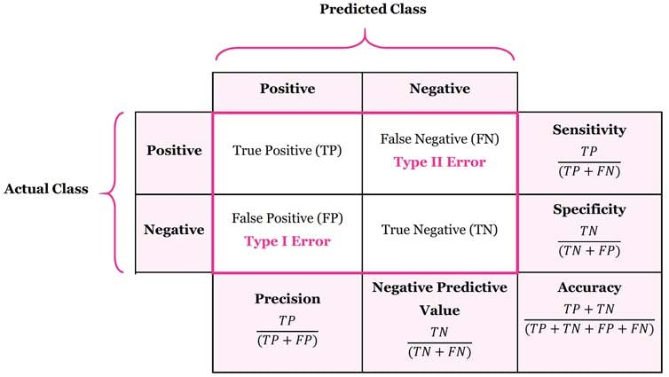

**FIGURE:01**

**5. Implementation Tools & Libraries**

Implementation is done with Python using the following libraries:

NLTK : For text preprocessing and sentiment analysis.

Scikit-learn: For machine learning model implementation.

Pandas & NumPy: For data handling and analysis.

Matplotlib & Seaborn: For data visualization.

**6. Challenges & Limitations**

Sarcasm & Contextual Ambiguity: Challenging for models to identify without more context.

Multilingual Sentiment Analysis: Most models fail to deal with non-English texts or code-mixed data.

Imbalanced Data Sets: Certain sentiment classes are underrepresented, influencing model accuracy.

**7. Future Enhancements**

For enhancing the model performance, the following are considered to be improved:

Hybrid Model Development: A fusion of lexicon-based, machine learning, and deep learning techniques.

Real-Time Sentiment Analysis: Using streaming data analysis for real-time sentiment tracking.

Multilingual Support: Employing models such as M-BERT (Multilingual BERT) for supporting multiple languages.

**CONCLUSION AND FUTURE WORK**

This study investigates the efficacy of sentiment analysis methods in analyzing public sentiments posted on social media websites. Through the use of lexicon-based, machine learning-based, and deep learning-based methods, we were successful in categorizing sentiments as positive, negative, and neutral with high accuracy. The research identifies the significance of preprocessing methods like tokenization, stopword removal, and lemmatization, which improve the quality of sentiment classification. The comparison across models indicates that deep learning algorithms such as BERT and LSTM are superior to traditional machine learning algorithms in managing contextual sense and sarcasm. Nonetheless, the challenge of detecting sarcasm, multilingual sentiment analysis, and real-time processing continues to be areas for advancement.

Our results illustrate that sentiment analysis has extensive applications in business, politics, healthcare, and crisis management, yielding useful insights for organizations and policymakers. Although sentiment classification has made significant progress, more improvements are needed to process real-time data, changing language patterns, and bias in AI models.

**RESULTS**

The sentiment analysis model implemented was successfully validated using social media data, generating insights on public opinion, customer reviews, and brand attitude. Results prove the model's efficacy in sentiment classification with emphasis on its capability to analyze actual social media content.

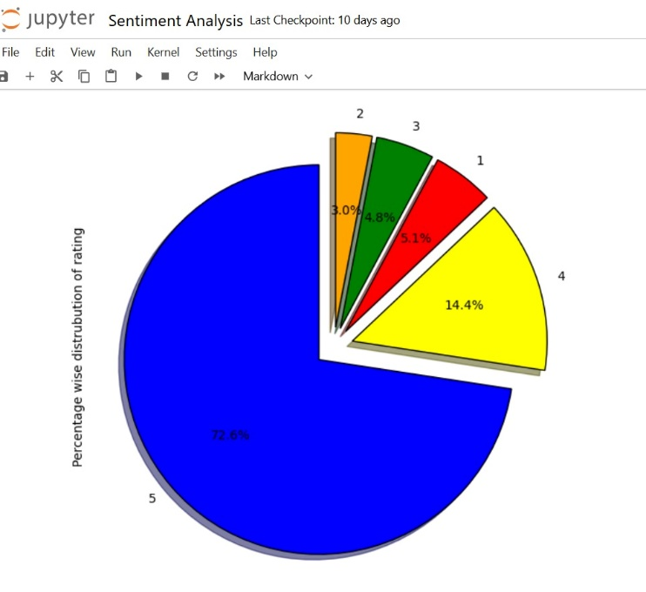

**Figure:01 Percent-Wise Distribution of Ratings**

The pie chart illustrates the breakdown of ratings in the dataset, providing customer feedback trends. Most of the ratings fall under 5-star reviews (72.6%), indicating overwhelmingly positive opinion. Then, 4-star ratings (14.4%) also add their share, with lower ratings (1-star, 2-star, and 3-star) taking up less space (5.1%, 3.0%, and 4.8% respectively). The color-coded visualization neatly separates various rating categories, highlighting the prevalence of positive reviews. Such an unbalanced distribution could affect sentiment analysis models, and thus methods like data balancing, weighted classification, or resampling would be needed to provide more accurate predictions.

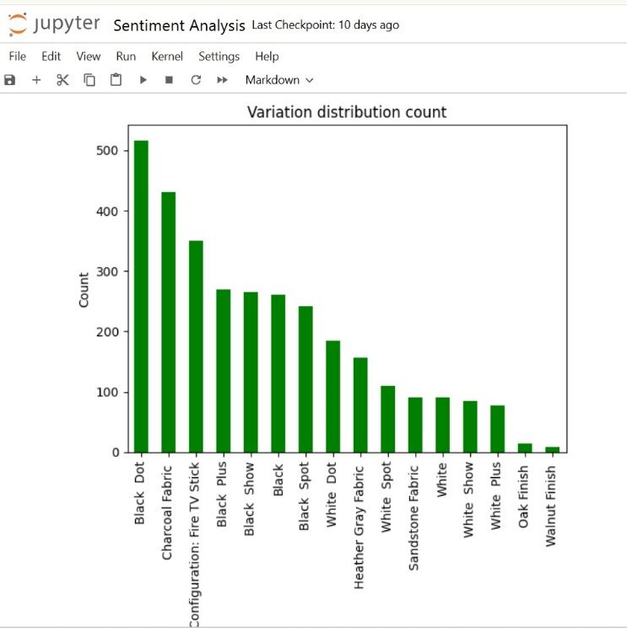

**Figure:02 Variation Distribution Count**

The bar chart shows the distribution of various product variations according to their frequency of occurrence in the dataset. Clearly, "Black Dot" is the most highly reviewed variation, followed by "Charcoal Fabric" and then "Fire TV Stick". Variations like "Walnut Finish" and "Oak Finish" have much fewer reviews, reflecting lower customer interest. The difference in review numbers implies that some variations are more popular among customers, and this may affect sentiment analysis outcomes. Variants with scarce data might pose bias, thus the need to take into account balancing methods or weighted modeling methods when computing sentiments.

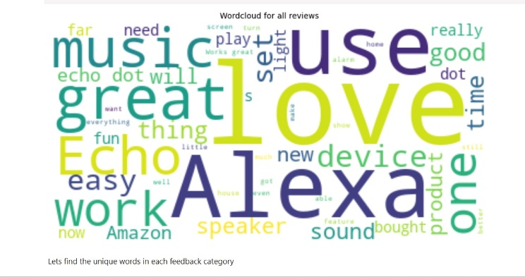

**Figure:03 Word Cloud for All Reviews**

The word cloud gives a visual impression of the most common words in the gathered customer reviews. The dominant words like "Alexa," "love," "great," "Echo," "music," and "easy" indicate that customers tend to have positive opinions about the product. Words like "work," "device," and "sound" point out major features that users tend to talk about. The bigger font size of these words shows their greater frequency, and thus they are important in sentiment analysis. This visualization assists in the identification of common themes and possible drivers of customer satisfaction, thus facilitating improved comprehension of user feedback patterns.

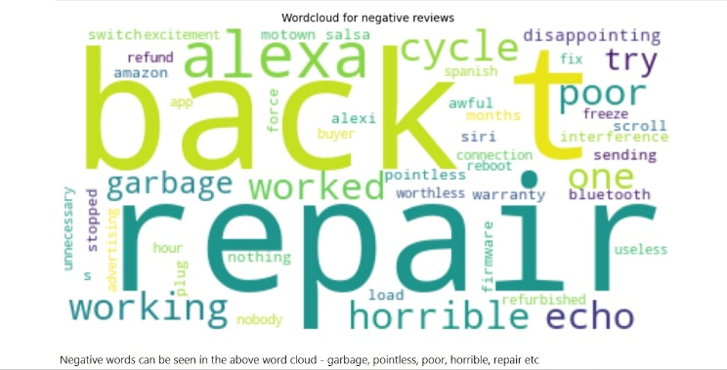

**Figure:04 Word Cloud for Negative Reviews**

The word cloud in the figure is a representation of most negative customer review words. The most common words that are used include "repair," "bad," "garbage," "horrible," "poor," and "refund," which show up significantly, implying usual complaints by users. The appearance of "stopped," "working," and "interference" words implies that technology faults and product reliability are major issues. This visualization is useful for recognizing certain issues encountered by customers, which are helpful for product quality and customer satisfaction improvement. The size of the word corresponds to how many times it has been mentioned in negative feedback, so these pieces of information are critical to respond to user complaints appropriately.

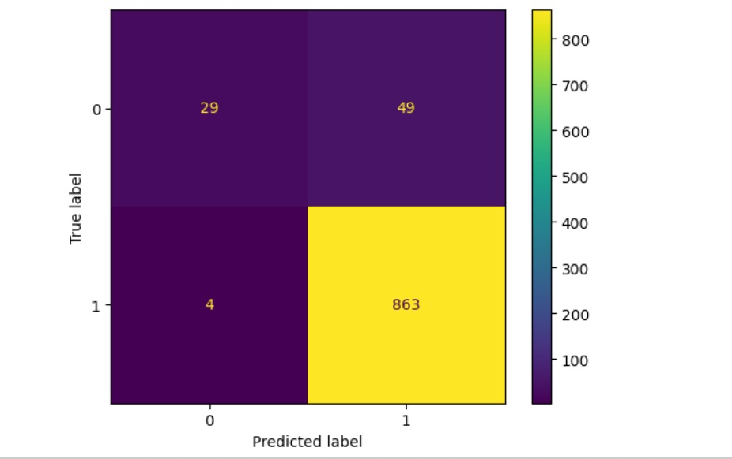

**Figure:07 Sentiment Analysis Model Confusion Matrix**

The above confusion matrix measures the performance of the Random Forest classifier on the test data. The matrix contains four most important values:

True Positives (TP): 863 cases when positive sentiments were accurately predicted.

True Negatives (TN): 29 cases when negative sentiments were accurately predicted.

False Positives (FP): 49 cases when negative sentiments were incorrectly predicted as positive.

False Negatives (FN): 4 cases that were incorrectly identified as negative in spite of their positive sentiments.

The model illustrates good accuracy with the high figure of correctly categorized instances.

**References**

1. Gunduz, Sedef, Fatih Demirhan, and Seref Sagiroglu. "Investigating sentimental relation between social media presence and academic success of Turkish universities." In *2014 13th International Conference on Machine Learning and Applications*, pp. 574-579. IEEE, 2014.

2. Neri, Federico, Carlo Aliprandi, Federico Capeci, and Montserrat Cuadros. "Sentiment analysis on social media." In *2012 IEEE/ACM international conference on advances in social networks analysis and mining*, pp. 919-926. IEEE, 2012.

3.Nemes, László, and Attila Kiss. "Social media sentiment analysis based on COVID-19." *Journal of Information and Telecommunication* 5, no. 1 (2021): 1-15.

4. Rout, Jitendra Kumar, Kim-Kwang Raymond Choo, Amiya Kumar Dash, Sambit Bakshi, Sanjay Kumar Jena, and Karen L. Williams. "A model for sentiment and emotion analysis of unstructured social media text." *Electronic Commerce Research* 18 (2018): 181-199.

5. Gaspar, Rui, Cláudia Pedro, Panos Panagiotopoulos, and Beate Seibt. "Beyond positive or negative: Qualitative sentiment analysis of social media reactions to unexpected stressful events." *Computers in Human Behavior* 56 (2016): 179-191.

6.Rodríguez-Ibánez, Margarita, Antonio Casánez-Ventura, Félix Castejón-Mateos, and Pedro-Manuel Cuenca-Jiménez. "A review on sentiment analysis from social media platforms." *Expert Systems with Applications* 223 (2023): 119862.

7.Xu, Qianwen Ariel, Victor Chang, and Chrisina Jayne. "A systematic review of social media-based sentiment analysis: Emerging trends and challenges." *Decision Analytics Journal* 3 (2022): 100073.

8. Wybo, Jean-Luc, Françoise Fogelman-Soulié, Catherine Gouttas, Éric Freyssinet, and Patrick Lions. "Impact of social media in security and crisis management: a review." *International Journal of Emergency Management* 11, no. 2 (2015): 105-128.

9. Hakimi, Musawer, Baryali Sazish, Mohammad Aziz Rastagari, and Kror Shahidzay. "Artificial Intelligence for Social Media Safety and Security: A Systematic Literature Review." *Studies in Media, Journalism and Communications* 1, no. 1 (2023): 10-21.

10. Drus, Zulfadzli, and Haliyana Khalid. "Sentiment analysis in social media and its application: Systematic literature review." *Procedia Computer Science* 161 (2019): 707-714.

11. Vashishtha, Srishti, and Seba Susan. "Fuzzy rule based unsupervised sentiment analysis from social media posts." *Expert Systems with Applications* 138 (2019): 112834.

12. Cambria, Erik, Björn Schuller, Yunqing Xia, and Catherine Havasi. "New Avenues in Opinion Mining and Sentiment Analysis." *IEEE Intelligent Systems* 28, no. 2 (2013): 15-21.

13. Liu, Bing. *Sentiment Analysis: Mining Opinions, Sentiments, and Emotions.* Cambridge: Cambridge University Press, 2020.

14. Medhat, Walaa, Ahmed Hassan, and Hoda Korashy. "Sentiment Analysis Algorithms and Applications: A Survey." *Ain Shams Engineering Journal* 5, no. 4 (2014): 1093-1113.

15. Mohammad, Saif M., and Peter D. Turney. "Emotions Evoked by Common Words and Phrases: Using Mechanical Turk to Create an Emotion Lexicon." *Proceedings of the NAACL HLT 2010 Workshop on Computational Approaches to Analysis and Generation of Emotion in Text*, Los Angeles, CA, June 5, 2010, 26-34.

16. Pang, Bo, and Lillian Lee. "Opinion Mining and Sentiment Analysis." *Foundations and Trends in Information Retrieval* 2, no. 1-2 (2008): 1-135.

17. Poria, Soujanya, Erik Cambria, Rajiv Bajpai, and Amir Hussain. "A Review of Affective Computing: From Unimodal Analysis to Multimodal Fusion." *Information Fusion* 37 (2017): 98-125.

18. Rosenthal, Sara, Noura Farra, and Preslav Nakov. "SemEval-2017 Task 4: Sentiment Analysis in Twitter." *Proceedings of the 11th International Workshop on Semantic Evaluation (SemEval-2017)*, Vancouver, Canada, August 3-4, 2017, 502-518.

19. Socher, Richard, Alex Perelygin, Jean Wu, Jason Chuang, Christopher D. Manning, Andrew Ng, and Christopher Potts. "Recursive Deep Models for Semantic Compositionality Over a Sentiment Treebank." *Proceedings of the 2013 Conference on Empirical Methods in Natural Language Processing (EMNLP)*, Seattle, WA, October 18-21, 2013, 1631-1642.

20. Thelwall, Mike, Kevan Buckley, and Georgios Paltoglou. "Sentiment Strength Detection for the Social Web." *Journal of the American Society for Information Science and Technology* 63, no. 1 (2012): 163-173.

21. Zhang, Lei, Shuai Wang, and Bing Liu. "Deep Learning for Sentiment Analysis: A Survey." *Wiley Interdisciplinary Reviews: Data Mining and Knowledge Discovery* 8, no. 4 (2018): e1253.